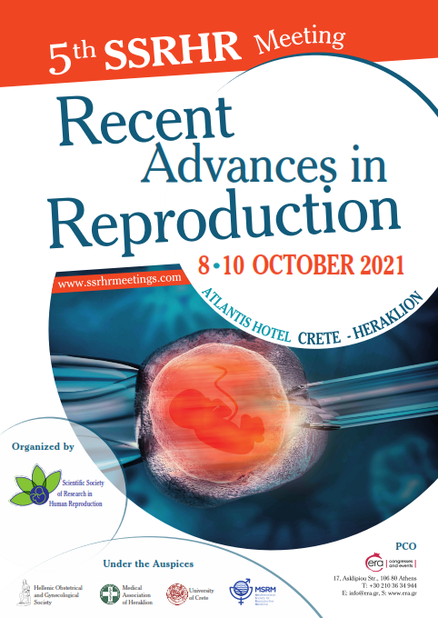
Invitation
Dear Colleagues and Friends,
On behalf of the Organizing and Scientific committee it is with great pleasure that I invite you to the 5th SSRHR meeting, to be held on 8-10 October 2021, at the Aquila Atlantis Hotel in Heraklion, Crete.
This year’s main topic is “Recent Advances in Reproduction” and for the 5th consecutive year, we have been working hard to bring together an exceptional scientific program, presenting all recent developments on diagnosis, best practice and research of Human Reproduction.
Taking into consideration the ongoing effect of the COVID 19 in our lives, it is clear that we need to be creative and flexible; therefore the 5th SSRHR meeting will be delivered as a hybrid event, with both face-to-face and online components, giving participants a greater flexibility to attend.
I trust that many of you will be able to travel to Heraklion, but for those unable to make it in person, we want to offer you the chance to attend the sessions and interact online, through the meeting’s digital platform.
With the hope that we will see each other in good health in October for another successful meeting!
Professor Antonis Makrigiannakis, MD, PHD
Meeting Chairman

Committees

Meeting Chairman: Antonis Makrigiannakis
Organising Committee
Antonis Makrigiannakis
Marianna Eustratiadou
Ιoannis Kokolakis
Dimitrios Koutroulakis
Georgios Manidakis
Nikolaos Martavantzis
Ioannis Messinis
Vasilis G. Mytaras
Artemis Pontikaki
Maria Rassidaki
Elpida Vardaki
Thomas Vrekoussis

Scientific Committee
Petros Drakakis
Timur Gurgan
Sofia Kalantaridou
Dimitris Loutradis
Antonis Makrigiannakis
Ιoannis Messinis
Tatjana Motrenko Simic
Hassan Sallam

PRELIMINARY SCIENTIFIC PROGRAM

Recent Advances in Reproduction

Friday 8 October 2021

 | HALL A
13:00-14:00 | REGISTRATIONS
14:00-16:00 | Oral Presentations I  Chairs: Marinos Nikolaou, Artemis Pontikaki
16:00-17:30 | Session I: Current aspects in PCOS  Chairs: Georgios Adonakis - Sofia Kalantaridou  - Does metformin or any other intervention prevent spontaneous abortion in PCOS?  Sofia Kalantaridou  - Lifelong impact for PCOS  Georgios Adonakis  - IVF in PCOS: Is it an easy or difficult decision?  Lucas D. Klentzeris  Comments: Konstantinos Dafopoulos
17:30-19:00 | Session II: How to increase Success before IVF  Chair: Petros Drakakis, Nikolaos Nikolettos  - Lifestyle effects in A.R.T.  Konstantinos Zikopoulos  - BMI and A.R.T. Should be corrected?  Dimitrios Goulis  - Should we check for thrombophilia before IVF?  Petros Drakakis  Comments: Sofia Kalantaridou
19:00 – 19:30 | Keynote Lecture  Chair: Antonis Makrigiannakis  Current Status of A.R.T.  Tatjana Motrenko Simic
20:00 | Opening Ceremony

Saturday 09 October 2021

 | HALL A
08:00 - 09:00 | Oral Presentations II  Chairs: Thomas Vrekoussis
09:00 -10:30 | Session III: Can surgery improve pregnancy: Results in infertility treatment  Chairs: Grigorios Grimbizis, Georgios Pados  - Can laparoscopic surgery improve pregnancy results?  Georgios Pados  - Can hysteroscopic surgery improve pregnancy results?  Minas Paschopoulos  - Hydrosalpinx-the role of tubal surgery in the era of A.R.T.  Marinos Nikolaou  Comments: Nikolaos Vlachos
10:30 -11:00 | Coffee break
11:00 - 12:30 | Session IV: Endometrium and A.R.T.  Chairs: Nikolaos Vlachos, Vasilios Tarlantzis  - Window of implantation and its disturbances  Georgios Nikas  - Manipulating the endometrium: can reccurent implantation failure be managed by the use of novel research therapies?  Antonis Makrigiannakis  - Treatment of thin endometrium  Evangelos Makrakis  Comments: Lucas D. Klentzeris
12:30-13:30 | Satellite Symposium - Leaving behind the gonadotrophins’ debate: The expert’s view  Chair: Konstantinos Kostaras  The role of uterine contractility in embryo implantation: novel approaches in diagnosis  Nikolaos Christoforidis  Sponsored by FERRING
13:30 – 14:00 | Satellite Lecture I  Sfakianoudis  Sponsored by MERCK
14:00 – 15:00 | Light break

15:00 - 16:30 | Session V: Ovarian stimulation in poor responders  Chairs: Dimitrios Loutradis, Georgios Adonakis  - Dual ovarian stimulation for poor prognosis patients  Nikolaos Nikolettos  - Parmacogenomics in COS: Control on Ovarian Stimulation  Dimitrios Loutradis  - Ovarian Stimulation in elective freezing  Ioannis Messinis  Comments: Vasilios Tarlantzis
16:30 – 17:00 | Coffee break
17:00-18:30 | Session VI: Endometriosis: UPdate  Chairs: Minas Paschopoulos, Konstantinos Zikopoulos  - The impact of ovarian hyper stimulation on endometriosis progression  Konstantinos Dafopoulos  - Endometrioma Surgery: Impact on A.RT.  Grigorios Grimbizis  - Fertility preservation in women with Endometriosis  Nikolaos Vlachos  Comments: Georgios Pados
19:00-20:00 | MSRM Session: SIG -ISIVF Endometrium RIF  Chair: Antonis Makrigiannakis  New ESHRE Clinic KPI-Maribor consensus  Tatjana Motrenko Simic  Comparison of Histone H3K4me3 between IVF and ICSI Technologies and between boy and girl offspring  Udo Jesche

Sunday 10 October 2021

 | HALL A
08:00 – 09:00 | Oral Presentations III  Chairs: Thomas Vrekoussis, Marinos Nikolaou
09:00- 10:30 | Session VII: Freeze oocyte- embryos  Chairs: Dimitrios Loutradis, Alexandros Daponte  - Do freeze all protocols increase success in IVF?  Vasilios Tarlantzis  - How to prepare the endometrium for frozen embryos embryo transfer?  Efstratios Kolibianakis  - Problems in pregnancy after transfer of frozen embryos  Antonis Makrigiannakis  Comments: Ioannis Messinis, Minas Mastrominas
10:30-11:00 | Satellite lecture II  Chair: Konstantinos Kostaras  - Vaginal Progesterone: Doctor choice in IVF.  Georgios Kontopoulos  Sponsored by Fertiland
11:00 - 11:30 | Coffee break
11:30 - 13:00 | Session VIII: Fertility Preservation  Chairs: Alexandros Daponte, Ioannis Giakoumakis  - Social freezing  Minas Mastrominas  - Fertility preservation for cancer patients  Alexandros Rodolakis  - Fertility preservation for infertility patients  Petros Drakakis  Comments: Nikolaos Vrahnis
13.00 – 13:30 | Lecture  Chair: Sifakis Stavros  - Pathofhysiology of Preeclampsia  George Papaioannou
13:30 – 14:30 | Open discussion - Conclusions

